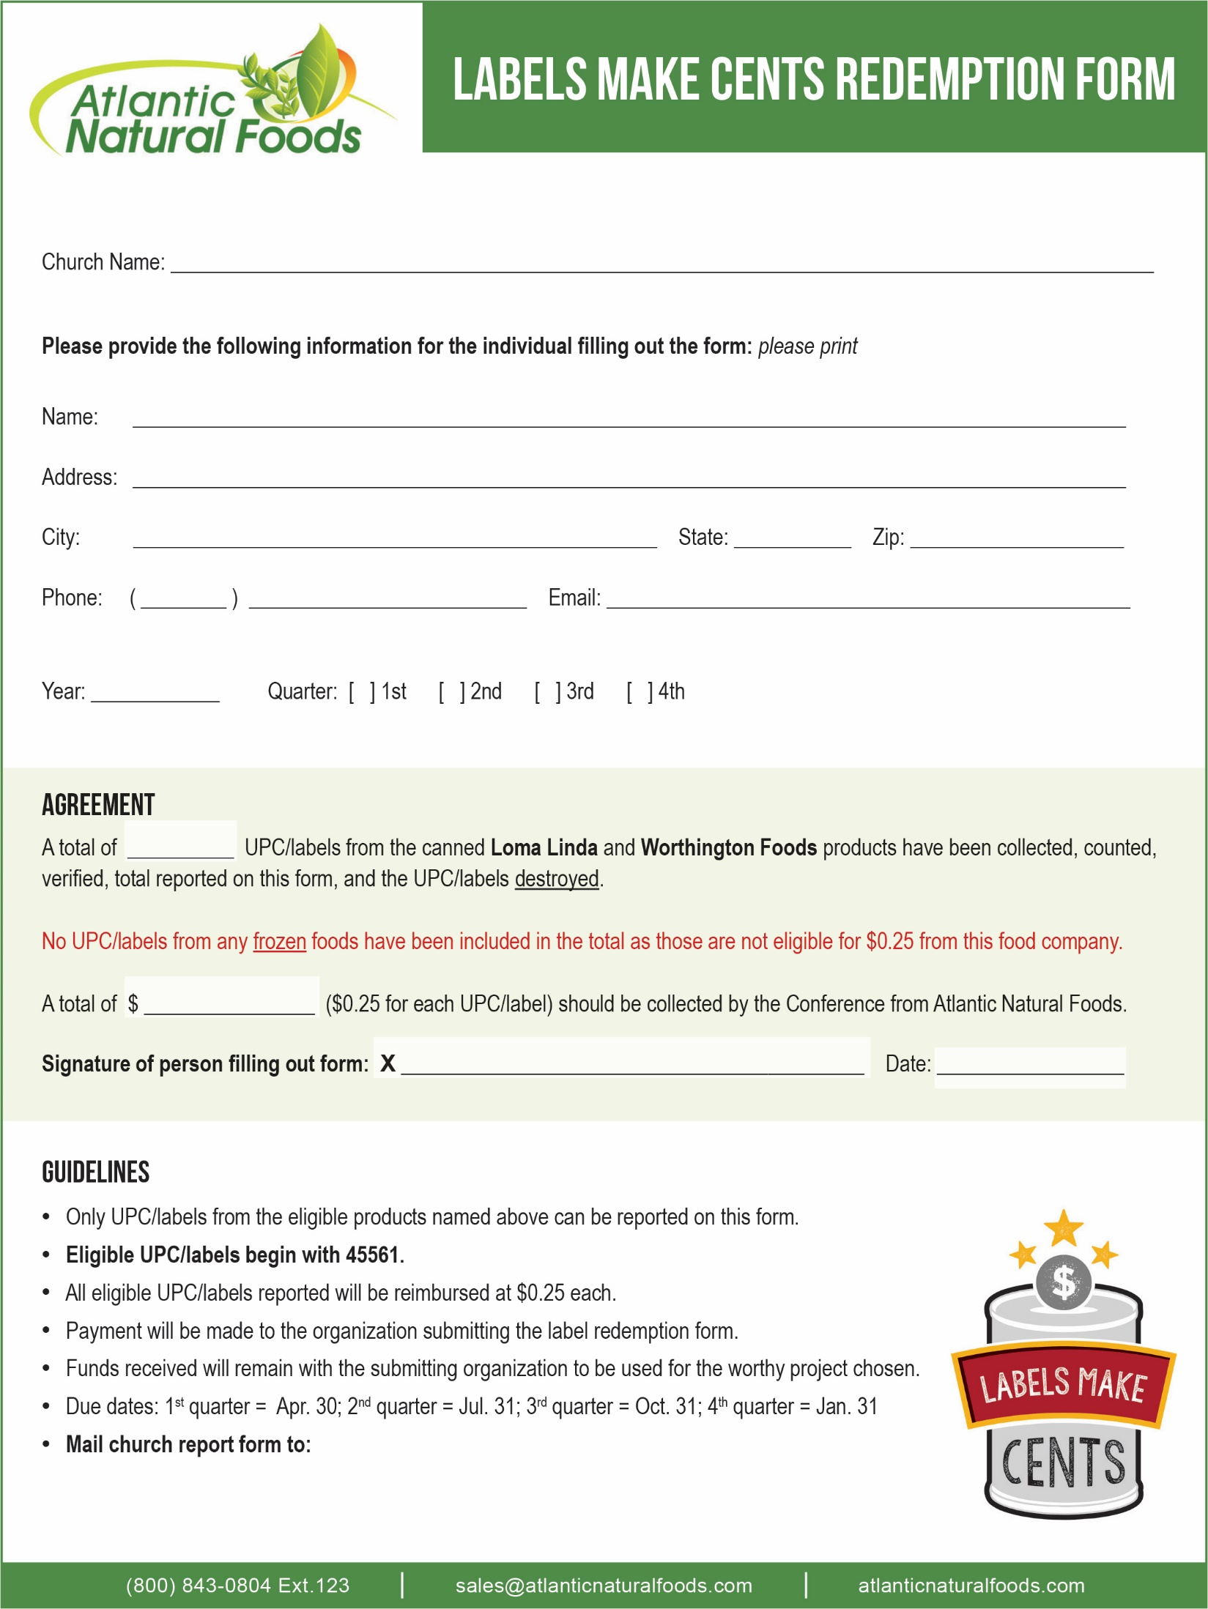

**Insert Organization or Contact Name**

**Insert Address**

**Insert City, State and ZIP**